***Assignment-2***

*Q.1*

**HTML FILE**

<html>

<head>

    <meta charset=”UTF-8”>

    <meta name=”viewport” content=”width=device-width, initial-scale=1.0”>

    <title>CSS Selectors Example</title>

    <link rel=”stylesheet” href=”style.css”>

</head>

<body>

    <h1>*******Welcome to My Website*******</h1>

    <p class=”main”>This is a example of class selectors.</p>

    <p id=”unique-element”>This is paragraph about ID selector</p>

    <p>This paragraph has no special class.</p>

    <ul>

        <li>Item 1</li>

        <li>Item 2 </li>

        <li>Item 3</li>

    </ul>

    <a href=”#”>Click Here</a>

</body>

</html>

**CSS FILE**

h1 {

    color: rgb(92, 68, 172);

    text-align: center;

    font-style: italic;

}

/* Class Selector - Targets elements with class="main" */

.main{

    font-style: italic;

    color: rgb(9, 9, 9);

    font-size: larger;

}

/* ID Selector - Targets an element with a specific ID */

#unique-element {

    font-weight: bold;

    background-color: rgba(218, 93, 176, 0.544);

    padding: 10px;

    border: 2px solid black;

}

/* Pseudo-Class Selector - Targets <a> when hovered */

a:hover {

    color: rgb(1, 39, 62);

    text-decoration: underline;

}

**OUTPUT:**

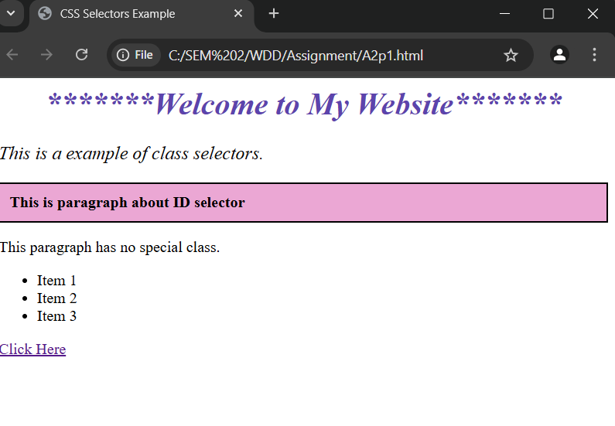

*Q.2*

<html lang="en">

<head>

    <meta charset="UTF-8">

    <meta name="viewport" content="width=device-width, initial-scale=1.0">

    <title>Box Model Example</title>

    <link rel="stylesheet" href="mystyle.css">

</head>

<body>

    <div class="box">

        <h1>This is a heading</h1>

        <p>This is a paragraph inside the div.</p>

    </div>

</body>

</html>

**CSS FILE**

/* Apply box model to div */

        .box {

            margin: 20px;

            border: 15px solid rgb(199, 7, 7);

            padding: 50px;

            box-sizing: border-box;

            background-color: rgb(188, 143, 231);

            text-align: center;

             }

        h1 {

            color: rgb(2, 34, 39);

        }

        p {

            color: rgb(16, 17, 0);

        }

**OUTPUT:-**

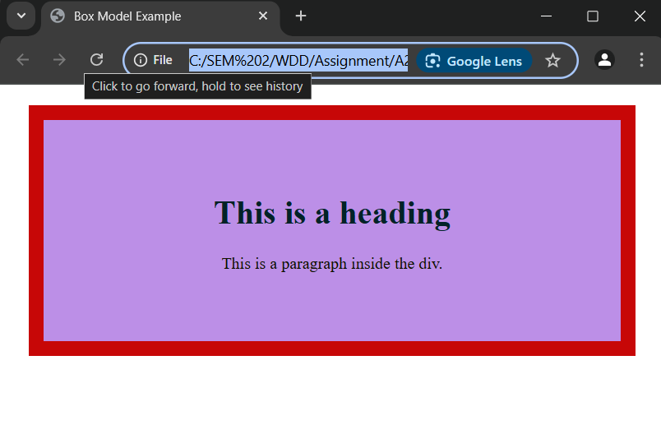

***Q.3***

<html>

    <head>

        <title>

            Registration form

        </title>

    </head>

    <body>

        <form>

        Enter Your FullName<br>

        <input type="text"><br>

        Enter Your Email<br>

        <input type="Email"><br>

        <input type="radio" name="gender" value="Male">Male

        <input type="radio" name="gender" value="Female">Female<br>

        <input type="checkbox" id="singing" name="interests" value="singing">singing

        <input type="checkbox" id="dancing" name="interests" value="dancing">dancing

        <input type="checkbox" id="art" name="interests" value="art">art

        <input type="checkbox" id="reading" name="interests" value="reading">reading<br>

        <br>Enter your Preferences for connecting you<br>

        <input type="radio" name="Preferred contact method" value="call">Call

        <input type="radio" name="Preferred contact method" value="SMS">SMS

        <input type="radio" name="Preferred contact method" value="Whatsapp">Whatsapp<br>

        <button type="submit">submit</button><br>

        <br><button type="reset">reset</button><br>

        </form>

    </body>

</html>

**OUTPUT:-**

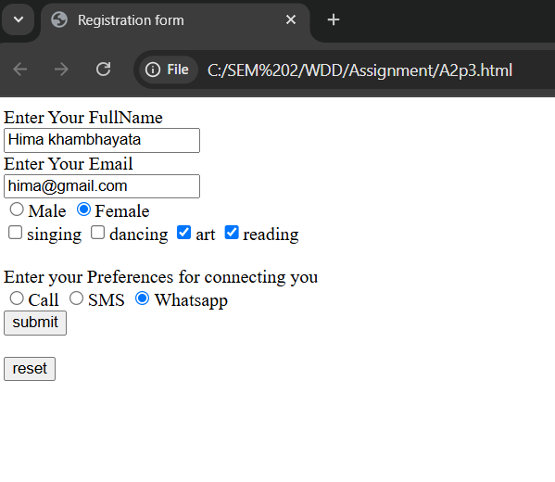

***Q.4***

<html lang="en">

<head>

    <meta charset="UTF-8">

    <meta name="viewport" content="width=device-width, initial-scale=1.0">

    <title>Media Query</title>

    <link rel="stylesheet" href="styles.css">

</head>

<body>

    <div class="box">

        <h1>This is a heading</h1>

        <p>This is a paragraph inside the div.</p>

    </div>

</body>

</html>

**CSS FILE**

.box {

    width: 80%;

    margin: 20px;

    border: 5px solid rgb(52, 2, 2);

    padding: 15px;

    box-sizing: border-box;

    text-align: center;

    background-color: rgb(78, 200, 241);

}

h1 {

    color: blue;

    font-size: 33px;

}

p {

    color: green;

    font-size: 18px;

}

@media screen and (max-width: 600px) {

    .box {

        background-color: rgb(240, 128, 128);

        text-align: center;

    }

    h1 {

        font-size: 24px;

    }

    p {

        font-size: 16px;

    }

}

**OUTPUT:-**

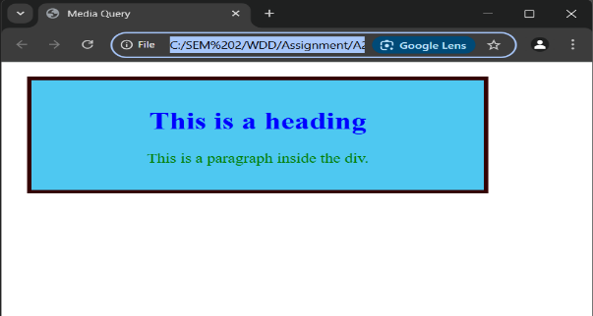

**2.**

